**EXERCISE 4 PART2**

**SELECT with various clause – WHERE, pattern matching**

**Q6**

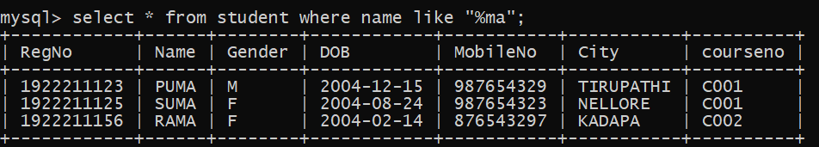

Q7

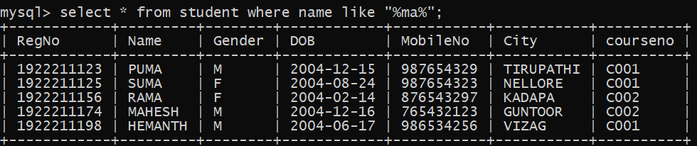

Q8

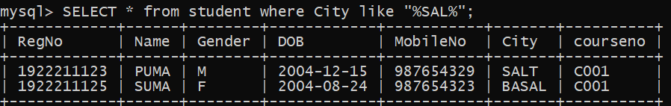

Q9

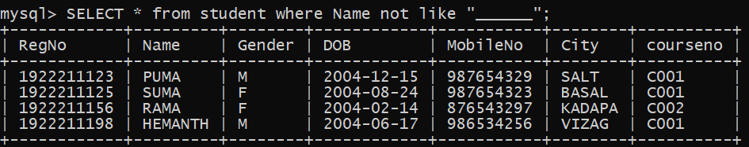

Q10

